SHARED PLANET
You and TİTAN HOTELS, it’s more than only holiday.
It’s our commitment to offer you a holiday in ways that are good to each other and the planet. From the way we buy goods and services, to minimizing our environmental footprint, to being involved in local communities. It’s doing things the way we always have. It’s using our name and image for the good. And because you support us, TİTAN HOTELS SHARED PLANET is what you are part of too.
ETHICAL RESOURCING
It’s our commitment to buy and serve the highest-quality responsibly manufactured, ethically traded goods to help create a better future for tourism and a more stable climate for our planet.
Goal: By 2016 100% of our goods will be responsibly manufactured and ethically traded.
ENVIRONMENTAL STEWARDSHIP
We are commited to minimizing our environmental footprint, tackling climate change and inspiring guests and business partners to do the same.
Goal: By 2016 we will significantly reduce our environmental footprint through energy and water conservation, recycling and our supplies will be environmentally friendly. We will prefer business partners who propagate environmental friendliness and dispose of an Environment Quality System.
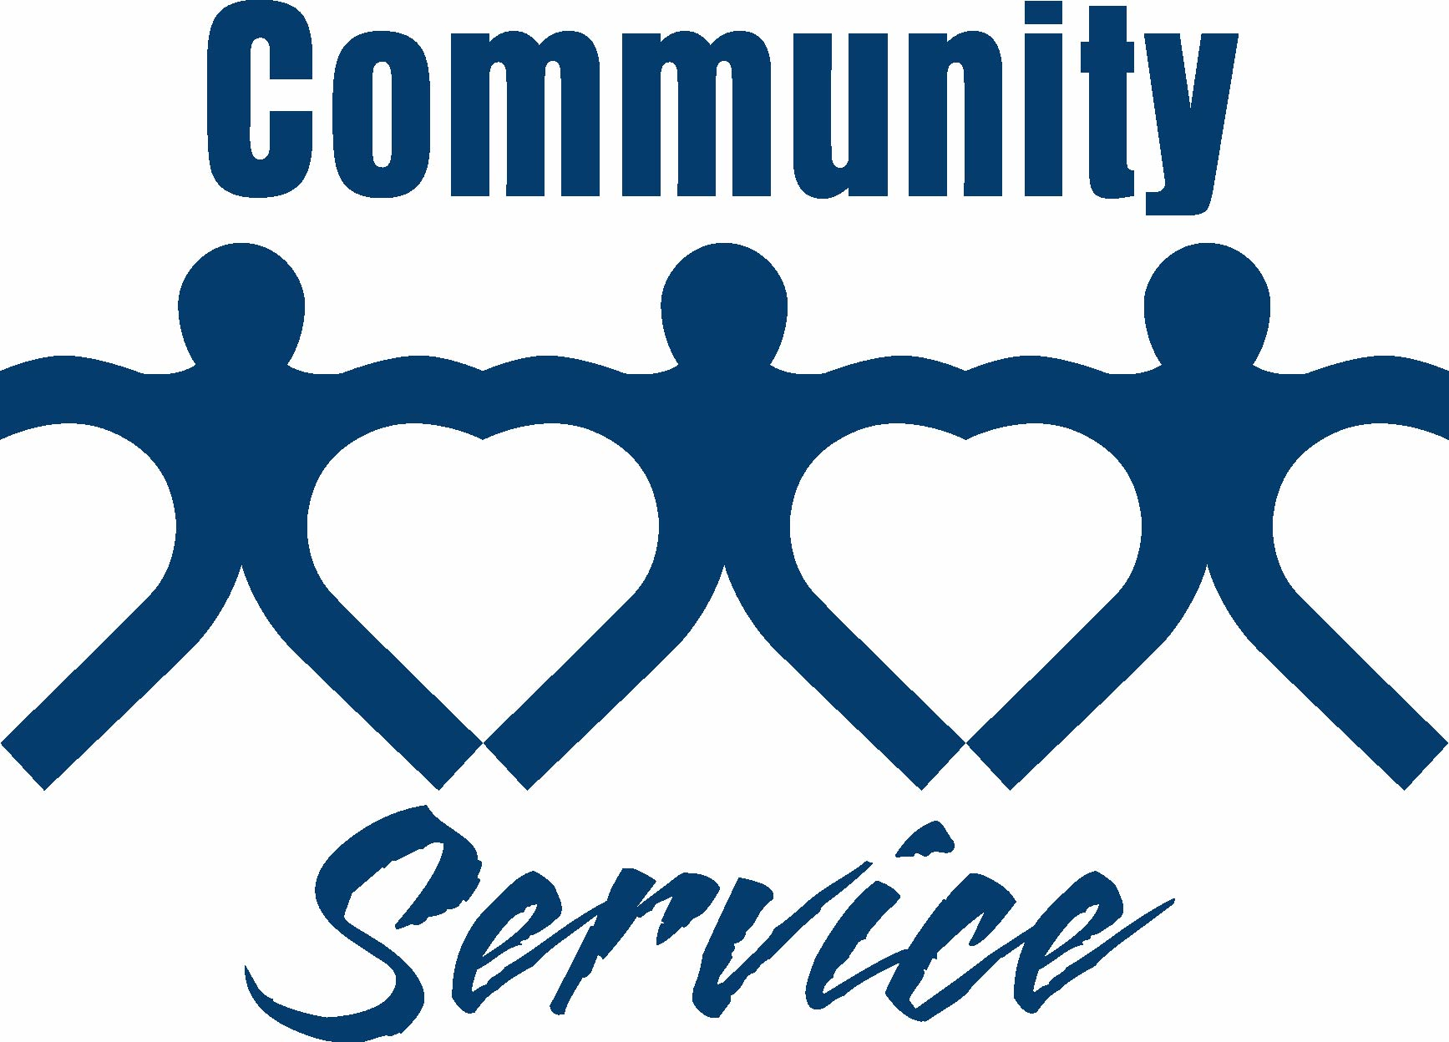

COMMUNITY INVOLVEMENT
We are commited to being a good neighbour and katalysator for change by bringing closer together our partners, our guests and our neighbourhood.
Goal: By 2016 we will have contributed more than 200 hours on community services.

TOGETHER WE MAKE TOMORROW MORE BEAUTIFUL

Here are some ways YOU can HELP us conserve the planet:
- Seperate your GARBAGE to stimulate RECYCLING.
- Use your BATHROOM TOWELS more often to REDUCE the use of CHEMICALS and WATER.
- Take a SHOWER instead of using your BATH TUB.
- Keep your MINIBAR closed to avoid unneccesary use of electricity.
- Throw your batteries in the BATTERY WASTE BIN in the lobby.
- Inform the management about WATER LEAKS.
- Keep your CURTAINS and BALCONY DOORS closed when you are outside your room to reduce the use of AIRDONDITIONING.
- Keep your balcony door closed while using the AIRCONDITIONING.
- Deliver your HAZARDOUS WASTE like empty AEROSOLS at the reception desk.
- Help to keep our BEACHES clean.
- Encourage your CHILDREN to do the same.

